 | 

Vietnamese title
English title

Họ và tên:
Student:
Giảng viên hướng dẫn:
Advisor:

TP. Hồ Chí Minh, tháng năm

English title

Họ và tên:
Student:
Giảng viên hướng dẫn:
Advisor:

Đại Học Kinh Tế Thành phố Hồ Chí Minh
Trường Công Nghệ và Thiết Kế
Viện Công Nghệ Thông Minh và Tương Tác

A Thesis
Submitted to Institute of Intelligent and Interactive Technologies
College of Technology and Design
University of Economics Ho Chi Minh City
in Partial Fulfillment of the Requirements
for the Degree of Bachelor of Engineering

December 2024
Ho Chi Minh City, Vietnam
Vietnamese title

Họ và tên: Giảng viên hướng dẫn:

Đại Học Kinh Tế Thành phố Hồ Chí Minh
Trường Công Nghệ và Thiết Kế
Viện Công Nghệ Thông Minh và Tương Tác

TÓM TẮT
Vietnamese Abstract。
Từ khóa:

English Title

Student: Advisor:

University of Economics Ho Chi Minh City
College of Technology and Design
Institute of Intelligent and Interactive Technologies

ABSTRACT
XXXX
Keywords:

ACKNOWLEDGEMENT

CONTENTS
TÓM TẮT iii
ABSTRACT iv
ACKNOWLEDGEMENT v
CONTENTS vi
LIST OF TABLES vii
LIST OF FIGURES viii
CHAPTER 1 INTRODUCTION 1
1.1 Research background 1
1.2 Research objective 1
1.3 Research organization 1
CHAPTER 2 LITERATURE REVIEW 2
CHAPTER 3 METHODOLOGY 3
CHAPTER 4 NUMERICAL RESULTS 4
CHAPTER 5 CONCLUSION 5
5.1 Conclusion and contribution 5
5.2 Limitation and further research 5
REFERENCES 6
APPENDIX 7

LIST OF TABLES

LIST OF FIGURES

INTRODUCTION

Research background
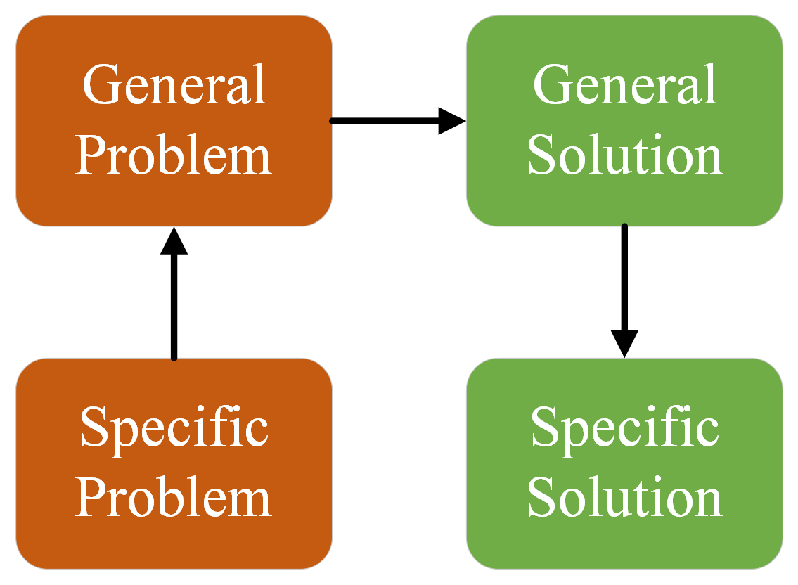
Figure 1. Figure captions

Research objective
Table 1. Table captions
Table header 1 | Table header 1

Research organization

LITERATURE REVIEW

METHODOLOGY

NUMERICAL RESULTS

CONCLUSION

Conclusion and contribution

Limitation and further research

REFERENCES
(IEEE style)
Basic format for books:
J. K. Author, “Title of chapter in the book,” in Title of His Published Book, xth ed. City of Publisher, (only U.S. State), Country: Abbrev. of Publisher, year, ch. x, sec. x, pp. xxx–xxx.
Examples:
- G. O. Young, “Synthetic structure of industrial plastics,” in Plastics, 2nd ed., vol. 3, J. Peters, Ed. New York, NY, USA: McGraw-Hill, 1964, pp. 15–64.
- W.-K. Chen, Linear Networks and Systems. Belmont, CA, USA: Wadsworth, 1993, pp. 123–135.

Basic format for periodicals:
J. K. Author, “Name of paper,” Abbrev. Title of Periodical, vol. x, no. x, pp. xxx-xxx, Abbrev. Month, year, DOI. 10.1109.XXX.123456.
Examples:
- J. U. Duncombe, “Infrared navigation—Part I: An assessment of feasibility,” IEEE Trans. Electron Devices, vol. ED-11, no. 1, pp. 34–39, Jan. 1959, 10.1109/TED.2016.2628402.
- E. P. Wigner, “Theory of traveling-wave optical laser,”
Phys. Rev.,
vol. 134, pp. A635–A646, Dec. 1965.
- E. H. Miller, “A note on reflector arrays,” IEEE Trans. Antennas Propagat., to be published.

Basic format for reports:
J. K. Author, “Title of report,” Abbrev. Name of Co., City of Co., Abbrev. State, Country, Rep. xxx, year.
Examples:
- E. E. Reber, R. L. Michell, and C. J. Carter, “Oxygen absorption in the earth’s atmosphere,” Aerospace Corp., Los Angeles, CA, USA, Tech. Rep. TR-0200 (4230-46)-3, Nov. 1988.
- J. H. Davis and J. R. Cogdell, “Calibration program for the 16-foot antenna,” Elect. Eng. Res. Lab., Univ. Texas, Austin, TX, USA, Tech. Memo. NGL-006-69-3, Nov. 15, 1987.

Basic format for handbooks:
Name of Manual/Handbook, x ed., Abbrev. Name of Co., City of Co., Abbrev. State, Country, year, pp. xxx-xxx.
Examples:
- Transmission Systems for Communications, 3rd ed., Western Electric Co., Winston-Salem, NC, USA, 1985, pp. 44–60.
- Motorola Semiconductor Data Manual, Motorola Semiconductor Products Inc., Phoenix, AZ, USA, 1989.

Basic format for books (when available online):
J. K. Author, “Title of chapter in the book,” in Title of Published Book, xth ed. City of Publisher, State, Country: Abbrev. of Publisher, year, ch. x, sec. x, pp. xxx–xxx. [Online]. Available: http://www.web.com
Examples:
- G. O. Young, “Synthetic structure of industrial plastics,” in Plastics, vol. 3, Polymers of Hexadromicon, J. Peters, Ed., 2nd ed. New York, NY, USA: McGraw-Hill, 1964, pp. 15-64. [Online]. Available: http://www.bookref.com.
- The Founders’ Constitution, Philip B. Kurland and Ralph Lerner, eds., Chicago, IL, USA: Univ. Chicago Press, 1987. [Online]. Available: http://press-pubs.uchicago.edu/
founders/
- The Terahertz Wave eBook. ZOmega Terahertz Corp., 2014. [Online]. Available: http://dl.z-thz.com/eBook/
zomega_ebook_pdf_1206_sr.pdf. Accessed on: May 19, 2014.
- Philip B. Kurland and Ralph Lerner, eds., The Founders’ Constitution. Chicago, IL, USA: Univ. of Chicago Press, 1987, Accessed on: Feb. 28, 2010, [Online] Available: http://press-pubs.uchicago.edu/founders/

Basic format for journals (when available online):
J. K. Author, “Name of paper,” Abbrev. Title of Periodical, vol. x, no. x, pp. xxx-xxx, Abbrev. Month, year. Accessed on: Month, Day, year, DOI: 10.1109.XXX.123456, [Online].
Examples:
- J. S. Turner, “New directions in communications,” IEEE J. Sel. Areas Commun., vol. 13, no. 1, pp. 11-23, Jan. 1995.
- W. P. Risk, G. S. Kino, and H. J. Shaw, “Fiber-optic frequency shifter using a surface acoustic wave incident at an oblique angle,” Opt. Lett., vol. 11, no. 2, pp. 115–117, Feb. 1986.
- P. Kopyt et al., “Electric properties of graphene-based conductive layers from DC up to terahertz range,” IEEE THz Sci. Technol., to be published. DOI: 10.1109/
TTHZ.2016.2544142.
Basic format for papers presented at conferences (when available online):
J.K. Author. (year, month). Title. presented at abbrev. conference title. [Type of Medium]. Available: site/path/file
Example:
- PROCESS Corporation, Boston, MA, USA. Intranets: Internet technologies deployed behind the firewall for
corporate productivity. Presented at INET96 Annual Meeting. [Online]. Available: http://home.process.com/
Intranets/wp2.htp

Basic format for reports and handbooks (when available online):
J. K. Author. “Title of report,” Company. City, State, Country. Rep. no., (optional: vol./issue), Date. [Online] Available: site/path/file
Examples:
- R. J. Hijmans and J. van Etten, “Raster: Geographic analysis and modeling with raster data,” R Package Version 2.0-12, Jan. 12, 2012. [Online]. Available: http://CRAN.R-project.org/package=raster
- Teralyzer. Lytera UG, Kirchhain, Germany [Online]. Available: http://www.lytera.de/Terahertz_THz_
Spectroscopy.php?id=home, Accessed on: Jun. 5, 2014

Basic format for computer programs and electronic documents (when available online):
Legislative body. Number of Congress, Session. (year, month day). Number of bill or resolution, Title. [Type of medium]. Available: site/path/file
NOTE: ISO recommends that capitalization follow the accepted practice for the language or script in which the information is given.
Example:
- U.S. House. 102nd Congress, 1st Session. (1991, Jan. 11). H. Con. Res. 1, Sense of the Congress on Approval of Military Action. [Online]. Available: LEXIS Library: GENFED File: BILLS

Basic format for patents (when available online):
Name of the invention, by inventor’s name. (year, month day). Patent Number [Type of medium]. Available: site/path/file
Example:
- Musical toothbrush with mirror, by L.M.R. Brooks. (1992, May 19). Patent D 326 189
[Online]. Available: NEXIS Library: LEXPAT File: DES

Basic format for conference proceedings (published):
J. K. Author, “Title of paper,” in Abbreviated Name of Conf., City of Conf., Abbrev. State (if given), Country, year, pp. xxxxxx.
Example:
- D. B. Payne and J. R. Stern, “Wavelength-switched pas- sively coupled single-mode optical network,” in Proc. IOOC-ECOC, Boston, MA, USA, 1985, pp. 585–590.
Example for papers presented at conferences (unpublished):
- D. Ebehard and E. Voges, “Digital single sideband detection for interferometric sensors,” presented at the 2nd Int. Conf. Optical Fiber Sensors, Stuttgart, Germany, Jan. 2-5, 1984.

Basic format for patents:
J. K. Author, “Title of patent,” U.S. Patent x xxx xxx, Abbrev. Month, day, year.
Example:
- G. Brandli and M. Dick, “Alternating current fed power supply,” U.S. Patent 4 084 217, Nov. 4, 1978.

Basic format for theses (M.S.) and dissertations (Ph.D.):
a) J. K. Author, “Title of thesis,” M.S. thesis, Abbrev. Dept., Abbrev. Univ., City of Univ., Abbrev. State, year.
b) J. K. Author, “Title of dissertation,” Ph.D. dissertation, Abbrev. Dept., Abbrev. Univ., City of Univ., Abbrev. State, year.
Examples:
- J. O. Williams, “Narrow-band analyzer,” Ph.D. dissertation, Dept. Elect. Eng., Harvard Univ., Cambridge, MA, USA, 1993.
- N. Kawasaki, “Parametric study of thermal and chemical nonequilibrium nozzle flow,” M.S. thesis, Dept. Electron. Eng., Osaka Univ., Osaka, Japan, 1993.

Basic format for the most common types of unpublished references:
a) J. K. Author, private communication, Abbrev. Month, year.
b) J. K. Author, “Title of paper,” unpublished.
c) J. K. Author, “Title of paper,” to be published.
Examples:
- A. Harrison, private communication, May 1995.
- B. Smith, “An approach to graphs of linear forms,” unpublished.
- A. Brahms, “Representation error for real numbers in binary computer arithmetic,” IEEE Computer Group Repository, Paper R-67-85.

Basic formats for standards:
a) Title of Standard, Standard number, date.
b) Title of Standard, Standard number, Corporate author, location, date.
Examples:
- IEEE Criteria for Class IE Electric Systems, IEEE Standard 308, 1969.
- Letter Symbols for Quantities, ANSI Standard Y10.5-1968.
Article number in reference examples:
- R. Fardel, M. Nagel, F. Nuesch, T. Lippert, and A. Wokaun, “Fabrication of organic light emitting diode pixels by laser-assisted forward transfer,” Appl. Phys. Lett., vol. 91, no. 6, Aug. 2007, Art. no. 061103.
- J. Zhang and N. Tansu, “Optical gain and laser characteristics of InGaN quantum wells on ternary InGaN substrates,” IEEE Photon. J., vol. 5, no. 2, Apr. 2013, Art. no. 2600111
Example when using et al.:
- S. Azodolmolky et al., Experimental demonstration of an impairment aware network planning and operation tool for transparent/translucent optical networks,” J. Lightw. Technol., vol. 29, no. 4, pp. 439–448, Sep. 2011.

APPENDIX

BIOGRAPHY

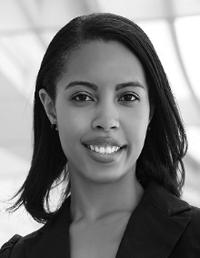
The student’s educational background is listed. The degrees should be listed with type of degree in what field, which institution, city, state, and country, and year the degree was earned.

The advisor’s educational background is listed. The degrees should be listed with type of degree in what field, which institution, city, state, and country, and year the degree was earned.

